**DAILY ONLINE ACTIVITIES SUMMARY**

|  |  |  |  |  |  |  |  |  |
| --- | --- | --- | --- | --- | --- | --- | --- | --- |
| **Date:** | **27-06-2020** | | | | | **Name:** | **Likhitha.M** | |
| **Sem & Sec** | **6th Sem ‘A’** | | | | | **USN:** | **4AL17CS046** | |
| **Online Test Summary** | | | | | | | | |
| **Subject** | | **-** | | | | | | |
| **Max. Marks** | | **-** | | **Score** | | | **-** | |
| **Pre-placement Training Summary** | | | | | | | | |
| **Course** | 1.DBMS2. JAVA AND J2EE | | | | | | | |
| **Certificate Provider** | | | **-** | | **Duration** | | | **4hr** |
| **Coding Challenges** | | | | | | | | |
| **Problem Statement:**  Write a program to print all permutations of a given string | | | | | | | | |
| **Status:Completed** | | | | | | | | |
| **Uploaded the report in Github** | | | | | **Yes** | | | |
| **If yes Repository name** | | | | | <https://github.com/likhithaMantaral/Daily-status> | | | |
| **Uploaded the report in slack** | | | | | **Yes** | | | |

Online Test Details:

-

Online Training Details:

Attended class on the topic DBMS from 9am to 11am

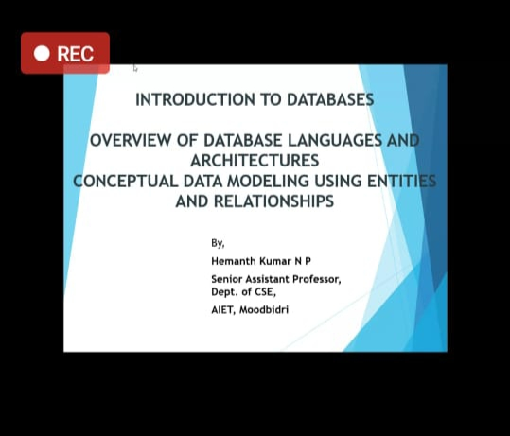

Attended class on the topic Java and J2EE from 11am to 1:30pm

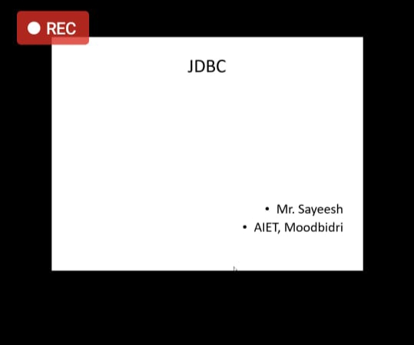

Coding Challenges Details:

Write a program to print all permutations of a given string.

Description:  
Here is the steps to implement string permutations:

Take out the first char and keep it constant. And permute rest of the characters.  
User recursive method call to permute rest of the string except first character.  
While making recursive call, we accumulate each character being constant along with recursive call response.

